All About Ms. Hardy

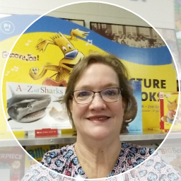

*Welcome to the Media Center! I am so excited to embark on a new school year. I look forward to working and partnering with you and your child this school year. I love to read and it is my job to instill in students that reading is fun. It is my goal to help grow your child academically, mentally, socially and emotionally into the amazing person that they are meant to be. We are on the Road to Success and I cannot wait to see where we end up!*

**My Hobbies**

I love spending time with my family, reading, and traveling to the beach and mountains.



**Where I’ve Taught**

This is my 15th year in the media center at Lindley. I have taught for 16 years but have been at Lindley the longest. My kids went to Lindley and it is an amazing school.

**My College**

I graduated college from **UNC Greensboro**

I graduated with a Bachelor of Art in Elementary Education. I received my Masters in Library Science from East Carolina Unversity.

**My Favorite Authors**

Eric Carle  
Sharon Draper  
Shel Silverstein  
Young Adult Authors

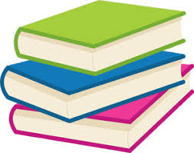

**My Family**

**My Granddogs**

**Winston, Whopper, Domino, Vesper**

**My Sports Team**

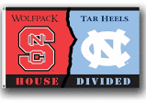

**What I love about Lindley…**

I love the partnership between the staff and community to ensure that all students grow at their highest potential as learners.

**#LindleyStrong**

**My Contact Info**

Robin Hardy

hardyr@gcsnc.com

336-294-7360